Report For Prototype_2







About App

The app has been created with the help of

HTML, JAVASCRIPT, PHP and a SQL database.

The data transfer after our app requests it starts from the openweathermap server where we use out data import php file which fetches data from the openweathermap server and transfers the data to our SQL database from where the data is requested by our api which then sent to the html/js file and then displayed on our weather app.

The PRO’s:

* **Reliability:** Previously, our program relied completely on the openweathermap server, now that we have a database that stores the data from the server every 10 seconds, so if for some reason the main server malfunctions, our app still has data to display.
* **Pricing:** This is a major upgrade for us as we are still using the free api service but because we have another api that’s ours we need not worry about the number of calls per minute.
* **Efficiency:** Our program is more efficient than last time as it automatically updates the weather data every 10 seconds compared to last time where we had to refresh it each time we wanted new data.

The CON’s:

* **Reliability:** Our App now heavily relies on the Mi-Linux server, Hence if the server fails, Our app stops working.
* **Pricing:** Our mi-linux server is a paid server so we aren’t using a free service anymore.
* **Data accuracy:** The data on our app is updated every 10 seconds meanwhile we used to have an app that displayed data as it was in that moment, now we have an app that displays 10 second old data.
* **Slower data:** The data is transferred in prototype 1 is faster than data transferred in prototype 2 as this time we have many more connections in between the app and the data compared to last time where we had a direct connection. Example prototype 1 takes 16ms meanwhile prototype 2 takes about 82ms.

***Link for prototype2:***

<https://mi-linux.wlv.ac.uk/~2241296/prototype2.html>

***UML Diagram:***

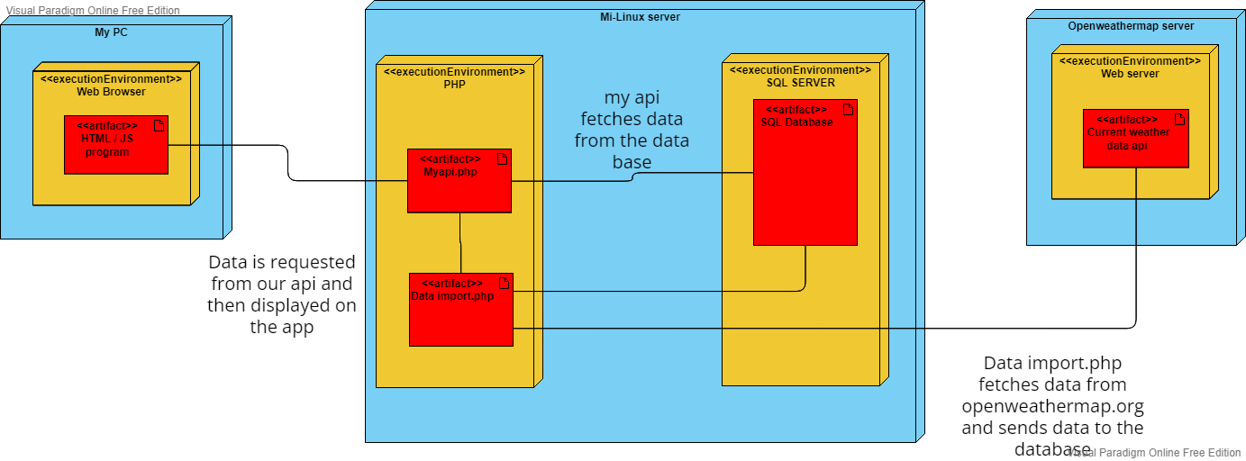

***SQL Database Screenshots***

